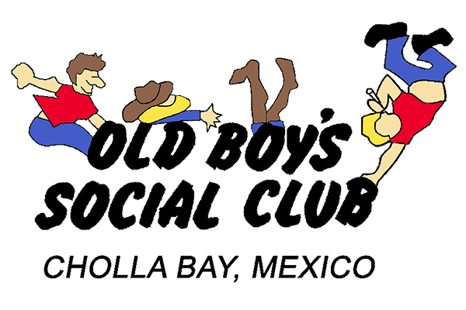
OBSC Meeting Minutes Sunday, January 14, 2024

Call to order: It’s 11:05 and time to rock! The scribe reported that the OBSC minutes are now officially called “hours:”, because it takes hours to do the minutes!
Scribe’s report: Minutes were accepted as read with corrections from Annette and Sue.
Treasurer’s report: Beginning balance was $ 5,315.27 (US). $ 5,109.80 (MX) Ending balance $ 4,470.64 (US) $ 7,789.80(MX). At this point there were inappropriate embezzlement jokes concerning Helen, Tucson Sue and Kathy and dollars and cruises.
Membership: We ended up 2023 with 170 members! We have not had this many members in years! The membership for 2024 is “in flux”. There was a mercifully short trip down memory lane concerning the “all male” OBSC of the 80’s. Sometime in the early 90’s women were allowed to join. The club founders concluded that the women were doing most of the work, so they may as be paying members.
Infirmary: Although Linda Perrotta’s surgery went well, it was noted that the Perrottas’ medical issues and social life were not a priority, because Annette pointed out they are not current mis embers. Betty Lopez is doing better. It was great to see Donna Schilling at the meeting after her cardiac scare. Harry reported that Sandy was recovering well from her shoulder surgery and would be back in Cholla soon and ready to party and report on Harry’s energy level. Harry noted that in Sandy’s absence, he stayed up to 1:00AM without being the least bit tired. Sue filled in for Sandy and told Harry he was tired AND to go home. Karen is having her shoulder surgery in a week. Cheryl reported that Tammy Kidd is having hip surgery in February. Pres Pat commented that “Damn! You people are getting old!”
Clothes Closet: Sue has embroidered Hawaiian shirts and “puffy” vest and not puppy vests. There are no dogs involved. Sue has embroidered short and long sleeve shirts.
Sargent at Arms: Craig Lyons was appointed Sargent at arms by Pat. Pat noted he always picks someone (such as Craig) who was not properly attired. Although Craig is not a new member, this was his first meeting. Pat was ready to grant a presidential pardon, but the membership chairman immediately vetoed the pardon. It was noted that Craig could take the OBSC underwear out of the frame, put them on and save a buck. Craig declined the offer and Harry thanked him. Craig tried to pay his fine with a coupon from last night’s party, but finally coughed up the $1 after getting change.
Social Media: At this point, Sue was busy selling shirts and was not paying attention to the meeting. Sue finally reported she only took 2 pictures at the party.
Building Committee: Harry repaired the toilet issues in both restrooms. Pat pointed out there still seemed to a leak at the urinal. Harry commented, in his professional plumber’s opinion, it was probably just bad aim. There is still a serious leak in the hoods above the fryers, but the usual leaks seem to have stopped. The roof got a good test after an inch of rain fell, but the leaks at the hoods are still an issue.
Old Business: 75 people attended the Winterfest and Annette signed up 10 new members. There was $1,650.00 was taken in at the door. Annette said we only made $15 on the animal races as they were a bit chaotic. Pat tried to get details on the gambling end of the races, but Lew was unable to provide details, due to wine. The meeting was pretty much out of control, but Harry got things back under control to hear the report on his tip jar. Annette reported Harry had $25 in the tip jar BUT, Annette’s tip jar (which is not at the bar) took in $16 and $20 pesos. This was a tip jar record! At a previous party, Harry primed the tip jar with a $20; at the end of the evening that 20 had swelled to $23. Tips from the tip jar go to a Cholla charity. Pat complemented the Caballeros on another great Winterfest and they received the traditional OBSC clap. Annette clarified that she is not ready to handle her door duties until 5:45 and all the early birds make her appear to be really disorganized. Pat made some sort of “broken record” comment in reply to Annette’s concern. Pat pointed out that whatever time we started, the early birds still appear. Annette also pointed out that she does not accept dues for the CBSC, Vecinos, girl scouts or boy scouts, just OBSC. There was a bit of confusion on Vecinos, CBSC and OBSC and who belonged to which group. The police breakfast went really well! It very a very cool event. Jerry was asked to get the financial end squared away and he was prepared with the receipts. The OBSC did not fund the event. It was funded by “the usual suspects”. Jerry would like to include the fire department next year. Jerry thanked all of the members who pitched in to help. The link sausage and hot cakes were a huge hit! Jerry pointed out the Commissioner is a great guy. He even hung around after most of the officers had left to wait for the police station custodian, who was running wait due to car problems. He is a very personable, friendly guy. The breakfast has gone a long way to promote Cholla Bay with the City officials. Harry felt that including the fire department, might be too many people to handle. He suggested we do two separate events.
New Business: Lew suggested we do an “Italian Mardi Gras” with the supplies from the cancelled spaghetti dinner. By popular demand, we will have another Cajun meal. Lew will take care of the dinner and Pat will delegate the parade to his assistant. The parade theme will be “some beach, somewhere”. This is easy theme for members to work with. St. Pat’s party will be March 16 and hosted by Harry & Sandy. We discussed getting a band for the April BBQ and many suggestions were made, although some were immediately “black balled”. In the last two years we had the Summer band, but there getting too expensive. Pat & Sue will hire a band soon.
Future dates:
St Pat’s dinner: March 16
April BBQ: April 20
Steak Fry: May 11
Spaghetti dinner/clean out the fridge: June 15

Meeting adjourned at approximately 11:55AM.
Submitted by Lew Felton, Scribe

